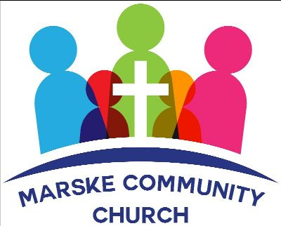

NEWSLETTER - JUNE 2022


Welcome to Marske Community Church's newsletter.
We meet every Sunday at 4.30pm at Marske Methodist Church, Hummershill Lane, Marske.
We also meet weekly on Wednesday at 7.30 pm for bible study and Friday at 9am for prayer
- please contact us if you would like further information.
We are available on facebook or email for prayer requests or simply a chat.

Our God is So Powerful!
A while back I bought a bike; a lovely new shiny bike – complete with basket on the front. I bought the safety stuff too – the helmet and gloves …. just in case. I imagined myself riding around like Mary Poppins – nipping to the shops even using it to get to work. I imagined using it when we were away on holidays, enjoying the scenery as I cycled through country lanes etc. Now you know I’m not the fittest of people – so I cheated and bought an electric assist bike! In my defense – you do still have to pedal! Anyway – before our last holiday I decided I needed to check it out – I planned on a quick ride around Marske. It was great – going downhill – not so great when it came to coming up the hill! When we were on holiday I tried it again – it was sooooo difficult! It didn’t feel like it had any power at all. My legs were like jelly. And my images of zooming around completely deserted me.
When we got home I decided to take the bike back to the shop to get it checked over – turns out there was a little wire disconnected and the electric assist wasn’t even working! No wonder I struggled up those hills!! Wow what a difference – it’s amazing …. and you may well see me nipping to the shops and going to work on it now that I’ve got that ‘assistance’.
This made me think about how we often try to do things in our own power – we do our best – and we get so far – but it’s hard, and sometimes we fail. Sometimes we might feel like we’re struggling the whole time – like everything is a real effort. The pressure of everyday life gets on top of us…. family – work – friends – finances – illness and pain – mental health … the list goes on.
Sometimes it might feel like we’re not quite connected to our Heavenly Father. We forget to pray. We forget to read our bible. We’re too busy and don't spend time with God. We lose our connection. No-one said being a Christian would be easy or solve all our problems – but what a difference to know that we’re ‘connected’ – connected to the King who created the universe and everything in it and holds us in His hands every day.
Praying that you all feel ‘connected’ to God – and if not – feel free to come and chat with us.
Ruth

June Services
Sunday 5 June - Simon Blake
Pentecost & Communion Service
Sunday 12 June - John Singleton
Sunday 19 June- Tim Myer
Fathers Day
Sunday 26 June - John Singleton
Shortened service followed by Tea and Church Meeting
Sunday 3 July - Geoff Bland
Communion
We are currently studying the book of James
We meet at
Marske Methodist Church, Hummershill Lane, Marske
The services begin at 4.30pm. Tea and Coffee served after the service.
We give a very warm welcome to you all
Due to new Covid-19 regulations, the wearing of masks is now a personal choice. We respect your wishes and encourage you to do whatever you are comfortable with.
Thank you

Tea & Coffee Rota
If you are able to help by joining the Tea and Coffee Rota - please let Ruth know and she will add you to the rota.
Thank you

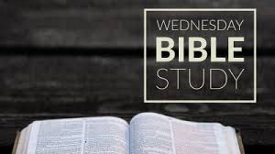
Every Wednesday at 7.30pm
You are very welcome to join us at our weekly Bible Study on
Wednesdays at 7.30pm.
We will be starting a new study on The Life of David.
We meet at the home of Brian and Ann - please contact us for further information


We truly believe that Prayer Changes Things!
Come and join us for prayer - Friday mornings at 9am
at Barry & Elizabeth's home
please contact us for further information

Stepping out in Faith
We believe that, now we are firmly established as a Christian presence in Marske and have a pattern of worship, sharing and teaching at our Sunday service, God wants us to take a significant step of faith as we seek to reach out to meet some of the needs of our community. Some of the current suggestions have been discussed at our leaders meeting and shared with others at our Bible Study on Wednesdays and at our Prayer meeting on Fridays.
But we need to be sure which of the ideas and suggestions are God’s way forward for us and not just a good idea!
Please feel free to ask what suggestions have been made and join us in praying and studying Scripture to discern God’s will. We want to hear from you if God gives you a word or a verse which will help to clarify the next step for us.

EXTRA NOTICES

Our Web Site is now live - http://www.marskecommunitychurch.uk - it is a work in progress - but we are hoping to develop this over the coming weeks. Any suggestions gratefully received. You can download sermons and newsletters from the 'Downloads' section on the site.
We continue to pray for those we know and love who are struggling with health issues at the moment. Especially Helena, Janet, Ann, Danny, Catherine, John Simms, Enid, Peter and Margaret. We praise God for answered prayers and trust Him to guide us as we pray.
Thank you for your continued generous giving.
If you would like the Church bank account details for regular or one off giving, please contact us at info@marskecommunitychurch.uk
Please keep your eyes and ears open for anyone who may need our support. Give them a call and/or contact us via email or phone so we can contact them

Thank you for reading our newsletter - if you have any suggestions or ideas for the future, please get in touch!
Please remember, if you have a prayer request, please email or speak to one of the leaders.
If you know anyone who would appreciate receiving this monthly letter, ask them to get in touch and we will happily add them to our mailing list.
Take care and God Bless.

Copyright © 2020| Marske Community Church All rights reserved.
Charity Number - 1197544
Our mailing address is:
64 Limes Crescent, Marske, TS11 7BU
We meet at:
Marske Methodist Church, Hummersill Lane, Marske, Sundays at 4.30pm
Email: info@marskecommunitychurch.uk
Find us on facebook - Marske Community Church
Web Site - www.marskecommunitychurch.uk

