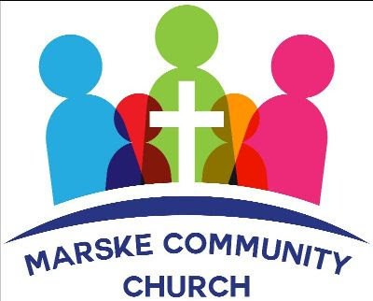

NEWSLETTER - MAY 2022


Welcome to Marske Community Church's newsletter
We meet every Sunday at 4.30pm at Marske Methodist Church, Hummershill Lane, Marske.
We also meet weekly on Wednesday at 7.30 pm for bible study
and Friday at 9am for prayer
- please contact us if you would like further information.
We are available on facebook or email for prayer requests or simply a chat.

AFTER EASTER – What now?!
When Easter is over, just like Christmas, there often seems to be a lack of excitement. The hot cross buns and Easter eggs are long gone, family catch ups are over, and its time for the children and young people to go back to school and for the adults to return to their normal daily work, whether paid or unpaid!
It’s so easy to forget the enormity of what Easter is all about.
The God, who loves each and every person, wanted a relationship with each one of us, and was prepared to send part of Himself, the Lord Jesus, to come down to earth to live as God and man. Jesus led a perfect, sinless life but paid the price for our sin by taking the sins of the world upon Himself dying on the cross of Calvary. Not only that but He overcame the ultimate fate of physical death by being raised back to life and being seen by over 500 people.
These facts should engender post Easter excitement for 3 reasons :-
- If we accept Jesus as our Saviour and Lord we can be sure that our sins are forgiven and that we are in a renewed relationship with a Holy God
- After His ascension back to heaven, Jesus sent the Holy Spirit to guide, strengthen and encourage each believer as we seek to lead a life pleasing to God
- We can be assured of our future as we have His promise that physical death is not the end but just a gateway to an eternal life in His presence.
May you know the excitement of a life lived with these promises fixed in our minds, influencing our day to day words and actions and being salt and light in our community.
Blessings
John Singleton
*****************************************************************************

May Services
Sunday 1 May - Brian Settle
Sunday 8 May - John Singleton
Communion Service
Sunday 15 May - Barry Dobson
Sunday 22 May - Phil Dixon
Sunday 29 May - John Singleton
We are currently studying the book of Daniel.
We meet at
Marske Methodist Church, Hummershill Lane, Marske
The services begin at 4.30pm. Tea and Coffee served after the service.
We give a very warm welcome to you all

Tea & Coffee Rota
If you are able to help by joining the Tea and Coffee Rota - please let Ruth know and she will add you to the rota.
Thank you
Every Wednesday at 7.30pm
You are very welcome to join us at our weekly
Bible Study on
Wednesdays at 7.30pm.
We are currently studying The Jesus that Paul knew.
We meet at the home of Brian and Ann - please contact us for further information



We truly believe that Prayer Changes Things!
A new weekly Prayer Meeting will be starting on
Friday 6 May 9am - 10am
To be held at Barry & Elizabeth's home
please contact us for further information
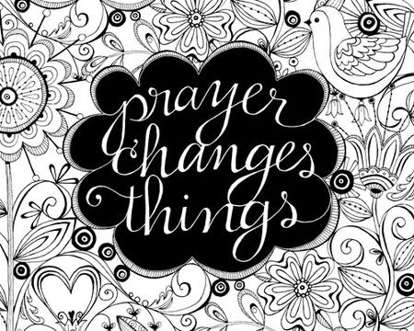
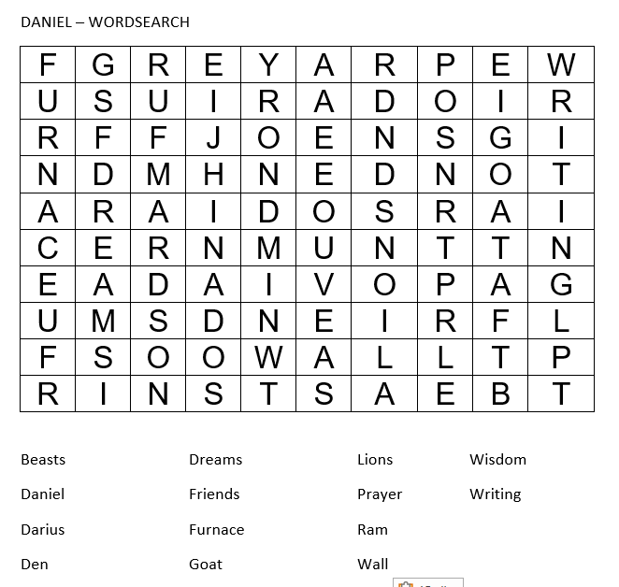

EXTRA NOTICES
Our Web Site is now live - http://www.marskecommunitychurch.uk - it is a work in progress - but we are hoping to develop this over the coming weeks. Any suggestions gratefully received. You can download sermons and newsletters from the 'Downloads' section on the site.
We continue to pray for those we know and love who are struggling with health issues at the moment. Especially Helena, Janet, Ann, Danny, Catherine, John Simms, Enid, Peter and Margaret. We praise God for answered prayers and trust Him to guide us as we pray.
Thank you for your continued generous giving.
If you would like the Church bank account details for regular or one off giving, please contact us at info@marskecommunitychurch.uk
Please keep your eyes and ears open for anyone who may need our support. Give them a call and/or contact us via email or phone so we can contact them

Thank you for reading our newsletter - if you have any suggestions or ideas for the future, please get in touch!
Please remember, if you have a prayer request, please email or speak to one of the leaders.
If you know anyone who would appreciate receiving this monthly letter, ask them to get in touch and we will happily add them to our mailing list.
Take care and God Bless.

Copyright © 2020| Marske Community Church All rights reserved.
Charity Number - 1197544
Our mailing address is:
64 Limes Crescent, Marske, TS11 7BU
We meet at:
Marske Methodist Church, Hummersill Lane, Marske, Sundays at 4.30pm
Email: info@marskecommunitychurch.uk
Find us on facebook - Marske Community Church
Web Site - www.marskecommunitychurch.uk
.

