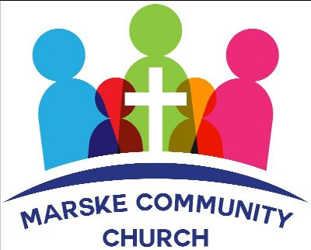

NEWSLETTER - APRIL 2022

Welcome to Marske Community Church's newsletter.
We meet every Sunday at 4.30pm.
We also meet weekly on Wednesday at 7.30 pm for prayer and bible study.
We meet at Marske Methodist Church, Hummershill Lane, Marske.
We are available on facebook, mobile or email for prayer requests or simply a chat
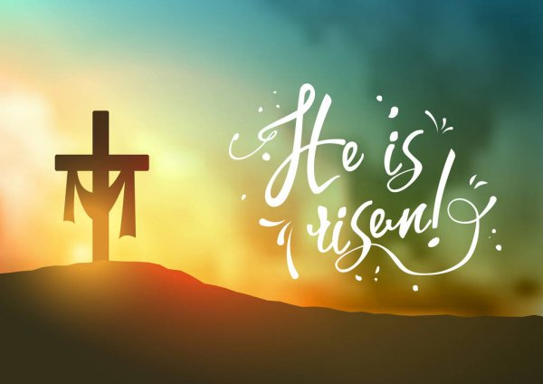
An Easter Message
There is an air of excitement and anticipation associated with Easter in our communities right now. The word conjures up thoughts of chocolate eggs and family days out with fun games for children such as treasure hunts. The prizes always consist of that tempting, tasty treat called chocolate!
“Wait a minute!” I hear you say, “where is Jesus in all of this? Isn’t He the reason for Easter?”
You are absolutely right! However, all these traditions have been absorbed by churches over the years as part of Easter celebrations and to point to the real events of Jesus’s death and resurrection. The egg is a clear symbol of new life which we experience when we follow Him. (“Therefore, if anyone is in Christ, the new creation is come. The old has gone, the new is here!” 2 Corinthians 5:17)
Some people like to roll eggs down a hill on Easter Sunday. This is a great game to play with children. It also makes me think of the angel rolling the stone away from the cave tomb where Jesus’s body lay after He was crucified. When the eggs are broken open there is treasure waiting inside for you. This is like the treasure that awaited the followers of Jesus when they discovered that He had broken free from death. He was not in the tomb, He was alive! The joy of the Easter egg hunt is achieved when an egg is found. The joy for a Christian is in finding Jesus as Lord, saviour, and friend. Jesus said, “Ask and it shall be given you; seek and you will find; knock and the door will be opened to you.” (Matthew 7 :7)
Of course, another popular tradition at Easter is eating those delicious hot cross buns. Many churches have them after a Good Friday service. The cross featured on these buns is the most important symbol for Easter, and for the whole year round! This is such a powerful reminder of Jesus’s incredible love for us. So, the cross tells us of his death, to give us life. It is an empty cross though and that says that he rose again. He is alive, hallelujah!
Happy Easter everyone.
Elizabeth

April Services
Sunday 3 April - John Singleton (Daniel chapter 3)
Sunday 10 April - Elizabeth Dobson
Friday 15 April - Reflective Good Friday Service
Communion Service
Sunday 17 April - John Singleton
Sunday 24 April- John Singleton (Daniel chapter 4)
Shortened service followed by Church Meeting
Sunday 1 May - Brian Settle (Daniel chapter 5)
We meet at
Marske Methodist Church, Hummershill Lane, Marske
The services begin at 4.30pm.
We give a very warm welcome to you all
Due to new Covid-19 regulations, the wearing of masks is now a personal choice. We respect your wishes and encourage you to do whatever you are comfortable with.
Thank you

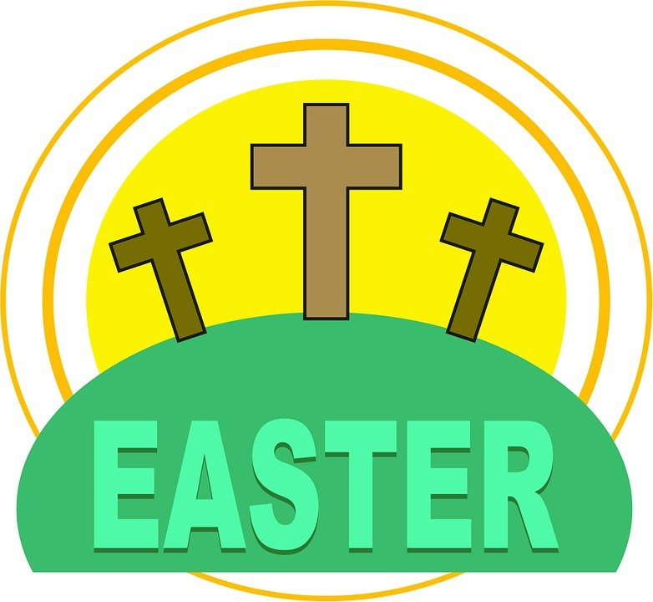
Good Friday - at 4.30pm We will hold a short reflective communion service - please join us.
Easter Sunday - at 4.30pm A celebratory service praising our Risen Jesus. This will include an Easter bonnet competition - for men, women and children!
Once again, we plan to bless neighbours with gifts of palm crosses and daffodils during Easter week.


Every Wednesday at 7.30pm at
Marske Methodist Church Hall
You are very welcome to join us at our weekly Prayer and Bible Study on
Wednesdays at 7.30pm.
We are currently studying The Jesus that Paul knew.

EXTRA NOTICES

Our Web Site is now live - http://www.marskecommunitychurch.uk - it is a work in progress - but we are hoping to develop this over the coming weeks. Any suggestions gratefully received. You can download sermons and newsletters from the 'Downloads' section on the site.
We continue to pray for those we know and love who are struggling with health issues at the moment. Especially Janet, Ann, Danny, Catherine, John Simms, Enid, Peter and Margaret. We praise God for answered prayers and trust Him to guide us as we pray.
Thank you for your continued generous giving.
If you would like the Church bank account details for regular or one off giving, please contact us at info@marskecommunitychurch.uk
Please keep your eyes and ears open for anyone who may need our support. Give them a call and/or contact us via email or phone so we can contact them

Easter Colouring (for adults and children!)

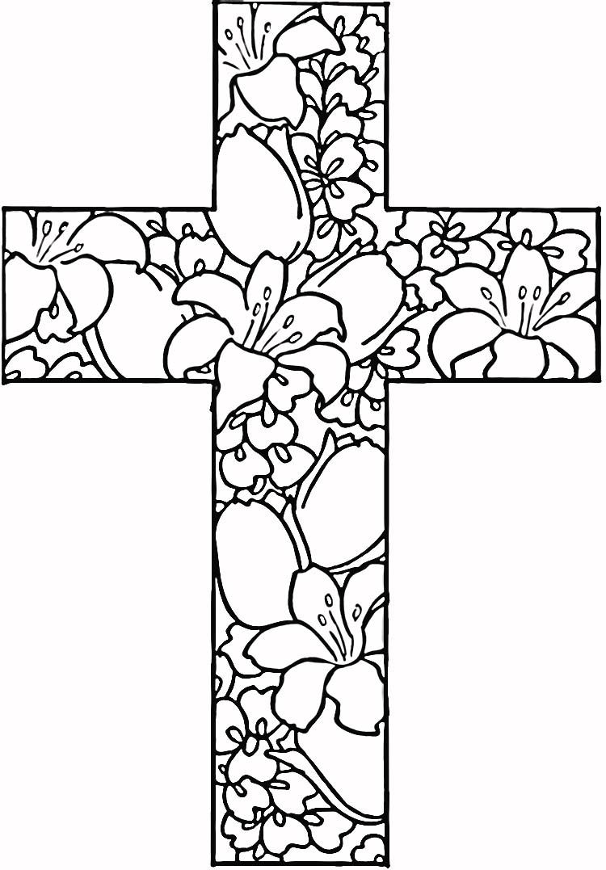
Thank you for reading our newsletter - if you have any suggestions or ideas for the future, please get in touch!
Please remember, if you have a prayer request, please phone, text or email.
If you know anyone who would appreciate receiving this monthly letter, ask them to get in touch and we will happily add them to our mailing list.
Take care and God Bless.

Copyright © 2020| Marske Community Church All rights reserved.
Charity Number - 1197544
Our mailing address is:
64 Limes Crescent, Marske, TS11 7BU
Email: info@marskecommunitychurch.ukFind us on facebook - Marske Community Church
Web Site - www.marskecommunitychurch.uk

