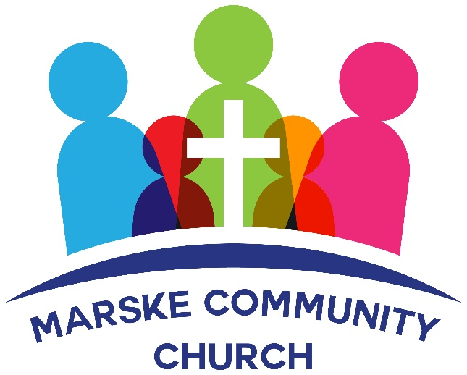

JANUARY 2022 NEWSLETTER –

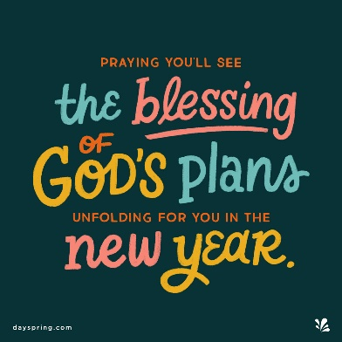
Welcome to Marske Community Church's New Year’s newsletter.
We meet every Sunday at 4.30pm.
We also meet weekly on Wednesday at 7.30 pm - currently for the Alpha Course.
We meet at Marske Methodist Church, Hummershill Lane, Marske.
We are available on facebook, mobile or email for prayer requests or simply a chat.
……………………………………………………………………………………………………………
MESSAGE FROM RUTH
Happy New Year! I wonder if you’ve made any New Year’s Resolutions? Or like me, have decided not to make any as you know you will only break them! I was watching a video clip this afternoon which basically said:
Instead of promising to fix all those things you’ve been meaning to fix – fix your eyes on Jesus
Instead of pledging to run on the treadmill every day – run the race marked out for you.
Instead of resolving to take up art classes, or swimming - resolve to take up your cross and follow Him
What changes do you think would happen if we all did these three things?
I’m convinced we would see some BIG changes, not only in our own personal lives, but for our Church and within our community.
Paul wrote to the Corinthians, “whatever you do, do it all for the glory of God” – if we do this our lives will shine with Jesus’s love – we will bring glory to God through simple acts of kindness – we will use the talents and gifts that God has given us to bring attention to Him.
This year let’s resolve to do all we do for the glory of God.
With love and best wishes for 2022 - Ruth
January Services
Sunday 2 January
Sunday 9 January
Sunday 16 January
Sunday 23 January
Sunday 30 January
We meet at
Marske Methodist Church, Hummershill Lane, Marske
The services begin at 4.30pm.
We give a very warm welcome to you all.
We continue to be cautious and sensible with regard to Covid-19 and encourage people to wear a mask whilst walking around the building, sanitize your hands and keep a distance of 1 meter +.
Thank you


Every Wednesday at 7.30pm at
Marske Methodist Church Hall
We will be resuming our weekly Prayer and Bible Study on
Wednesday 12 January 2022 at 7.30pm.
We will be starting a study on Elisha.



If you aim to read the whole bible during 2022 - why not use this app to help you ....
https://bibleinoneyear.org/en/
The Bible in One Year is a daily Bible reading plan which takes you through the whole Bible in 365 days. It is ideal for anyone who is looking for an easy and accessible way to read and understand the Bible.
Each day includes passages from a Psalm or Proverb, the New Testament and the Old Testament along with a daily commentary from Nicky and Pippa Gumbel, leaders of Holy Trinity Brompton (HTB) Church in London and pioneers of Alpha. The Bible in One Year will encourage you to engage more closely with the Bible, to apply its teachings to everyday life and to grow in your relationship with Jesus.
You can follow along by reading the text or listening to the audio commentary and you can choose the version that best suits your lifestyle; the Classic version (25 minutes), or a shorter Express or Youth version (both around 15 minutes).

.

Below are a few special verses for you to ponder on as we go into the New Year ....
Therefore, if anyone is in Christ, he is a new creation; old things have passed away; behold, all things have become new.
You are the light of the world. A city on a hill cannot be hidden. Neither do people light a lamp and put it under a bowl. Instead they put it on its stand, and it gives light to everyone in the house. In the same way, let your light shine before men, that they may see your good deeds and praise your Father in heaven.
And he who was seated on the throne said, “Behold, I am making all things new.”
Be anxious for nothing, but in everything by prayer and supplication with thanksgiving let your requests be made known to God.
Faith never knows where it is being led, but it loves and knows the One who is leading.
Remember not the former things, nor consider the things of old. Behold, I am doing a new thing; now it springs forth, do you not perceive it? I will make a way in the wilderness and rivers in the desert.

CHURCH MEMBERSHIP

If you would like to formally be a member of Marske Community Church,
please complete the form, available from Church
(or email info@marskecommunitychurch.uk)

EXTRA NOTICES

We continue to pray for those we know and love who are struggling with health issues at the moment. Especially Janet, Danny, Catherine, John Simms, Enid, Peter and Margaret. We praise God for answered prayers and trust Him to guide us as we pray.

Thank you for your continued generous giving.
If you would like the Church bank account details for regular or one off giving, please contact us at info@marskecommunitychurch.uk

Please keep your eyes and ears open for anyone who may need our support. Give them a call and/or contact us via email or phone so we can contact them.

